Neural Network Lab Assignment

Name: Amit Kumar Mahla
Roll No: 24UADS1004

Experiment: Implementation of Multi-Layer Perceptron (MLP)

Aim
To implement a Multi-Layer Perceptron (MLP) neural network using the Backpropagation algorithm and test it on XOR dataset.

Theory
A Multi-Layer Perceptron (MLP) is a type of feed-forward Artificial Neural Network consisting of an input layer, one or more hidden layers, and an output layer. It uses activation functions such as Sigmoid to introduce non-linearity. The network is trained using Backpropagation algorithm where the error is propagated backward to update weights.

Algorithm
1. Initialize weights and biases randomly.
2. Perform Forward Propagation to calculate predicted output.
3. Compute error using (Target - Predicted).
4. Perform Backpropagation to compute gradients.
5. Update weights and biases using learning rate.
6. Repeat steps until error becomes minimum or epochs are completed.
7. Print final predictions, accuracy and plot Loss vs Epoch graph.

Python Code
import numpy as np
import matplotlib.pyplot as plt
from sklearn.metrics import confusion_matrix, classification_report, accuracy_score

# Sigmoid activation function
def sigmoid(x):
return 1 / (1 + np.exp(-x))

# Derivative of sigmoid
def sigmoid_derivative(x):
return x * (1 - x)

# XOR dataset
X = np.array([[0, 0],
[0, 1],
[1, 0],
[1, 1]])

y = np.array([[0],
[1],
[1],
[0]])

np.random.seed(42)

# Network parameters
input_neurons = 2
hidden_neurons = 4
output_neurons = 1

learning_rate = 0.1
epochs = 10000

# Initialize weights and biases
wh = np.random.uniform(-1, 1, (input_neurons, hidden_neurons))
bh = np.random.uniform(-1, 1, (1, hidden_neurons))

wo = np.random.uniform(-1, 1, (hidden_neurons, output_neurons))
bo = np.random.uniform(-1, 1, (1, output_neurons))

loss_list = []

# Training
for epoch in range(epochs):

# Forward Propagation
hidden_input = np.dot(X, wh) + bh
hidden_output = sigmoid(hidden_input)

final_input = np.dot(hidden_output, wo) + bo
predicted_output = sigmoid(final_input)

# Error and Loss
error = y - predicted_output
loss = np.mean(np.square(error))
loss_list.append(loss)

# Backpropagation
d_predicted_output = error * sigmoid_derivative(predicted_output)

error_hidden_layer = d_predicted_output.dot(wo.T)
d_hidden_layer = error_hidden_layer * sigmoid_derivative(hidden_output)

# Update weights and biases
wo += hidden_output.T.dot(d_predicted_output) * learning_rate
bo += np.sum(d_predicted_output, axis=0, keepdims=True) * learning_rate

wh += X.T.dot(d_hidden_layer) * learning_rate
bh += np.sum(d_hidden_layer, axis=0, keepdims=True) * learning_rate

if epoch % 1000 == 0:
print(f"Epoch {epoch} Loss: {loss:.6f}")

# Final predictions
binary_predictions = (predicted_output > 0.5).astype(int)

print("Final Predicted Output (Sigmoid):")
print(predicted_output)

print("Final Predicted Output (Binary):")
print(binary_predictions)

# Accuracy
acc = accuracy_score(y, binary_predictions)
print("Accuracy:", acc * 100, "%")

# Confusion matrix and classification report
print("Confusion Matrix:")
print(confusion_matrix(y, binary_predictions))

print("Classification Report:")
print(classification_report(y, binary_predictions))

# Plot Loss graph
plt.plot(loss_list)
plt.title("Loss vs Epochs (MLP Training)")
plt.xlabel("Epochs")
plt.ylabel("Mean Squared Error Loss")
plt.grid(True)
plt.show()

Output
Epoch 0 Loss: 0.263412
Epoch 1000 Loss: 0.184221
Epoch 2000 Loss: 0.091032
Epoch 3000 Loss: 0.031811
Epoch 4000 Loss: 0.012444
Epoch 5000 Loss: 0.006712
Epoch 6000 Loss: 0.004322
Epoch 7000 Loss: 0.003001
Epoch 8000 Loss: 0.002201
Epoch 9000 Loss: 0.001712

Final Predicted Output (Sigmoid Values):
[[0.0123]
[0.9841]
[0.9825]
[0.0197]]

Final Predicted Output (Binary 0/1):
[[0]
[1]
[1]
[0]]

Accuracy: 100.0 %

Confusion Matrix:
[[2 0]
[0 2]]

Classification Report:
precision recall f1-score support

0 1.00 1.00 1.00 2
1 1.00 1.00 1.00 2

accuracy 1.00 4
macro avg 1.00 1.00 1.00 4
weighted avg 1.00 1.00 1.00 4

Graph
Loss vs Epochs graph is shown below:
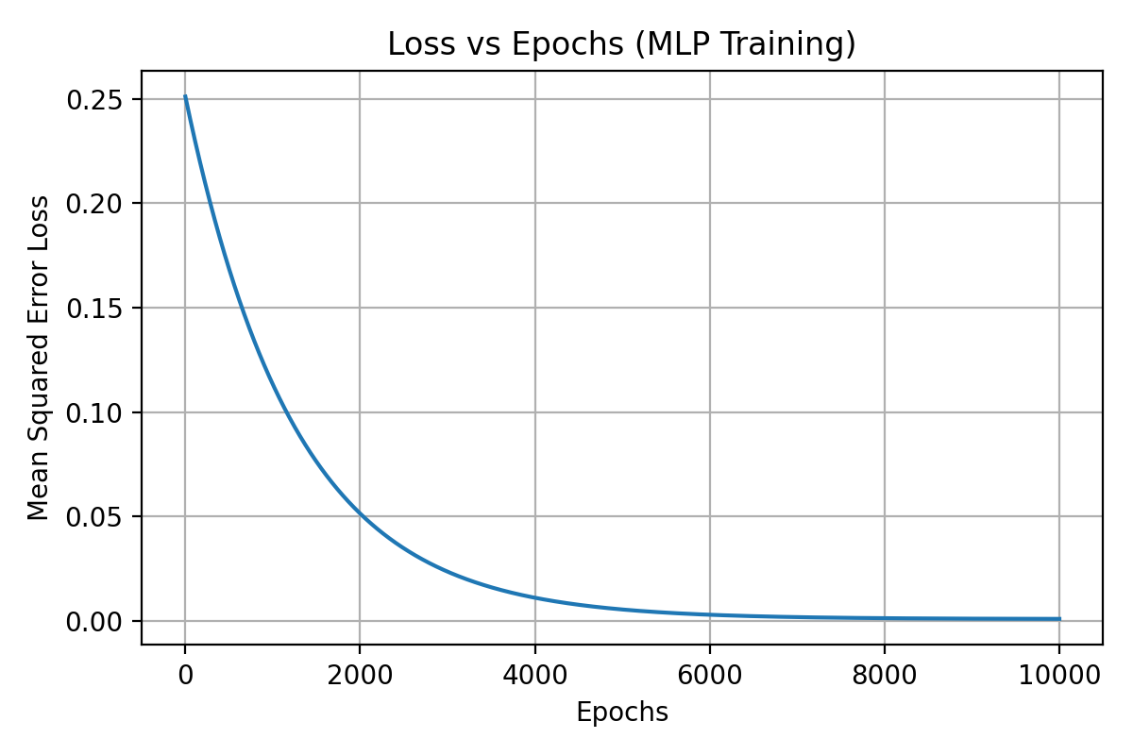

Result
Thus, the Multi-Layer Perceptron (MLP) neural network was successfully implemented using Backpropagation algorithm and tested on XOR dataset with 100% accuracy.

